**Student Linked List**

**Done By:** Rohit Karunakaran **Roll No:** 58

**Aim:** The details of students are to be stored in a linked list.

**Data Structures used:** Linked List

**Algorithm for Searching**

**Input:** Roll no (RN) of the student to be searched, and the Header node of the linked list

**Output:** A pointer to the corresponding student, if the number exists in the linked list, NULL in all other cases

**Data Structure:** Linked List

**Steps**

1. Step 1: Start
2. Step 2: ptr = Header→link //points to the first node in the list
3. Step 3: if(ptr==NULL)
4. Step 1: The linked List is empty
5. Step 2: return NULL
6. Step 4: else
7. Step 1: while(ptr!=NULL) do
8. Step 1: if(ptr→rollNo == RN) the
9. Step 1: EndWhile
10. Step 2: endif
11. Step 2: endwhile
12. Step 3: if(ptr==NULL) then
13. Step 1: return NULL
14. Step 4: else
15. Step 1: return ptr
16. Step 5: endif
17. Step 5: Stop

**Algorithm for Sorting**

**Input:** The Header Node of the Linked list to be sorted

**Output :** The Header node of the sorted Linked list

**Data Structure :** Linked List

**Steps**

* 1. Step 1: Start
  2. Step 2: if(Header→link == NULL) then
  3. Step 1: print(“The List is empty”)
  4. Step 3: else
  5. Step 1: temp = getNode(Node)
  6. Step 2: ptr = Header→link
  7. Step 3: while(Header→link!=NULL) do
  8. Step 1: ptr = Header→link
  9. Step 2: Header→link = ptr→link
  10. Step 3: if(Header→link == NULL) then
  11. Step 1: Header→link = ptr
  12. Step 2: ptr→link = NULL
  13. Step 4: else
  14. Step 1: ptr2 = temp→link
  15. Step 2: ptr1 = temp
  16. while(ptr2!=NULL and ptr2→rollNo<=ptr→rollno) do
  17. Step 1: ptr2 = ptr2→link
  18. Step 2: ptr1 = ptr1→link
  19. Step 4: endwhile
  20. Step 5: ptr1→link = ptr
  21. Step 6: ptr→link = ptr2
  22. Step 5: endif
  23. Step 4: EndWhile
  24. Step 5: Header→link = temp→link
  25. Step 6: returnNode(temp)
  26. Step 4: endif
  27. Step 5:return Header
  28. Step 6: Stop

**Program Code**

/********************************

* Linked List Implementation

* Done By: Rohit Karunakaran

* ******************************/

#include<stdio.h>

#include<stdlib.h>

typedef struct Linked_List_Node

{

struct Linked_List_Node *link;

int rollNo;

double mark;

char name[40];

}Student;

void initList(Student* Header)

{

//Header = (Student*) malloc (sizeof(Student));

Header->link = NULL;

}

void clearList(Student **List)

{

Student* ptr = *List;

Student *eat = ptr;

ptr = ptr->link;

if(ptr!=NULL)

{

free(eat);

ptr = ptr->link;

}

}

void getStudentData(Student* node)

{

printf("\nEnter the name of the student: ");

scanf("%[^\n]%*c",node->name);

printf("Enter the roll no: ");

scanf("%d",&node->rollNo);

printf("Enter the marks: ");

scanf("%lf",&node->mark);

printf("\n");

}

//Searching Algorithm

Student* searchFor(Student* Header, int rollNo)

{

Student* ptr = Header;

if(Header->link == NULL){

printf("The List is Empty\n");

return NULL;

}

else

{

while(ptr!=NULL)

{

if(ptr->rollNo == rollNo)

{

return ptr;

}

ptr = ptr->link;

}

return NULL;

}

}

//Sorting algorithm

void sortStudentList(Student** Header)

{

if((*Header)->link==NULL)

{

printf("The List is empty]\n");

}

else

{

Student *temp =(Student*) malloc(sizeof(Student));

Student *ptr=NULL;

temp->link=(*Header)->link;

(*Header)->link = NULL;

while(temp->link!=NULL)

{

ptr = temp->link;

temp->link = ptr->link;

if((*Header)->link ==NULL)

{

(*Header)->link = ptr;

ptr->link = NULL;

}

else

{

Student *ptr2=(*Header)->link;

Student *ptr1 =(*Header);

while(ptr2!=NULL && ptr2->rollNo<=ptr->rollNo)

{

ptr2=ptr2->link;

ptr1=ptr1->link;

}

ptr1->link=ptr;

ptr->link = ptr2;

}

}

free(temp);

}

}

void dispStudent(Student* ptr)

{

printf("\nName: %s",ptr->name);

printf("\nRoll No: %d",ptr->rollNo);

printf("\nMarks: %lf",ptr->mark);

}

//Insertion Algorithms

void insertStart(Student *Header)

{

Student *new_node = (Student*) malloc(sizeof(Student));

if(new_node!=NULL)

{

getStudentData(new_node);

new_node->link = NULL;

Student* ptr = Header->link;

Header->link = new_node;

new_node->link=ptr;

}

else

{

printf("Insertion Not Possible\n");

exit(1);

}

return ;

}

void deletionAt(Student* Header, int rollNo)

{

if(Header->link == NULL)

{

printf("Deletion not possible. The list is empty\n");

}

else

{

Student* ptr = Header;

while(ptr->link!=NULL)

{

if(ptr->link->rollNo==rollNo)

break;

ptr=ptr->link;

}

if(ptr->link!=NULL)

{

Student* red = ptr->link;

ptr->link = ptr->link->link;

printf("The Student to be deleted is :\n");

dispStudent(red);

free(red);

}

else

{

printf("The Given RollNo is not found \n");

}

}

}

void displayList(Student* Header)

{

Student* ptr = Header->link;

if(ptr!=NULL)

{

while(ptr!=NULL)

{

printf("\n");

dispStudent(ptr);

printf("\n");

ptr=ptr->link;

}

printf("\n");

}

else

{

printf("The Linked list is empty\n");

}

}

int menu(Student* Header)

{

int RUN = 1;

while(RUN)

{

printf("\n");

printf("=============================\n");

printf(" MENU \n");

printf("=============================\n");

printf("1.Insert\n");

printf("2.Delete Student\n");

printf("3.Display the linked List\n");

printf("4.Search for a Student by Roll No\n");

printf("5.Sort By Roll No\n");

printf("6.Exit\n");

printf("Enter Choice: ");

int choice;

int pos;

scanf("%d%*c",&choice);

switch(choice)

{

case 1:

insertStart(Header);

printf("\n");

break;

case 2: printf("Enter the roll no of the student to be deleted : ");

scanf("%d%*c",&pos);

deletionAt(Header,pos);

printf("\n");

break;

case 3: printf("\nThe Student List is : ");

displayList(Header);

break;

case 4: printf("Enter the roll Number to be searched for : ");

scanf("%d%*c",&pos);

Student* res = searchFor(Header,pos);

if(res == NULL)

{

printf("The given roll number is invalid !!!\n");

}

else

{

dispStudent(res);

}

break;

case 5: sortStudentList(&Header);

printf("The sorted list is :\n");

displayList(Header);

break;

case 6: RUN=0;

break;

default: printf("Enter a valid choice\n");

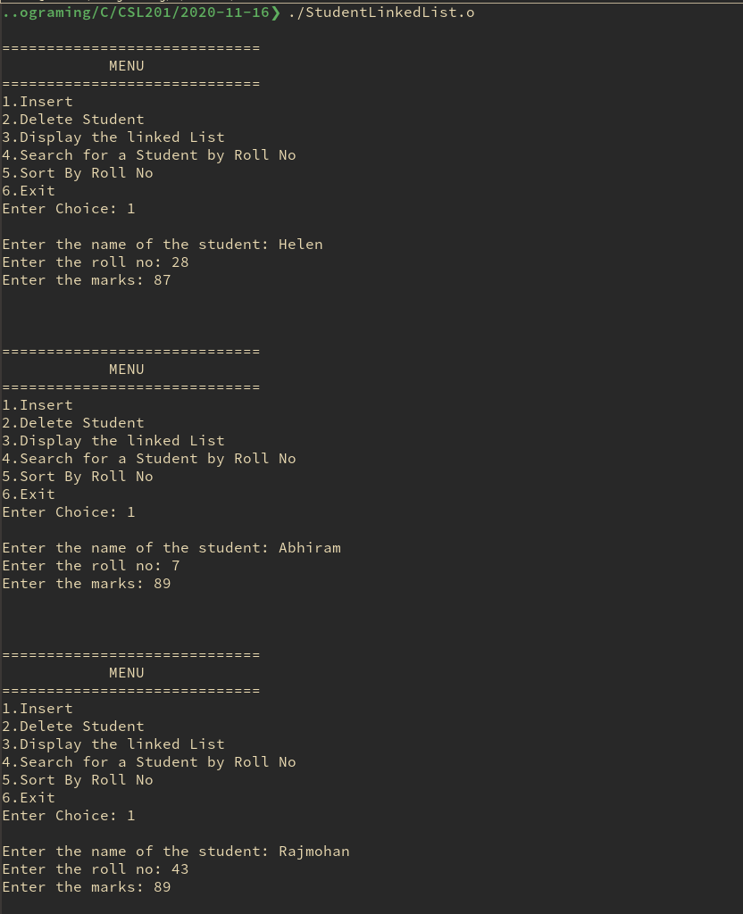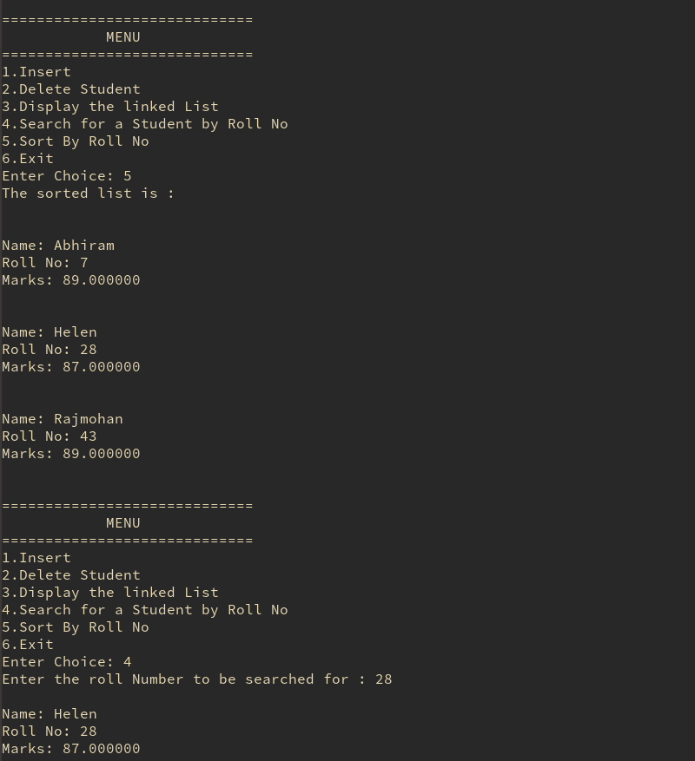 printf("\n");

break;

}

}

printf("Exiting........\n");

clearList(&Header);

return RUN;

}

int main()

{

Student *Header = (Student*)malloc(sizeof(Student));

initList(Header);

return menu(Header);

}

**Sample input output**

